**BUSINESS ETHICS REPORT**

**University of Salford**

**@00600575**

**Executive Summary**

O2 Band Pro is an organisation that aims to achieve a massive reduction in fuel consumption through creating parts for internal combustion engines or petrol and diesel-based cars. With public groups and governments pushing the automotive industry to comply towards ethical practices, this has changed the dynamics of the sector from sourcing, manufacturing and post-sales processes. With the electrification of vehicles and cleaner technology, the industry has still faced issues navigating towards them, which was explored through doughnut model, providing a global view, and value chain, providing practices for a circular economy and regenerative design within operations.

For O2 Band Pro to proceed with the transformations within the industry, their contributions towards the SDG Goals 7 and 13 were analysed. This brought realisation that companies of that scale have succeeded so far by establishing strong relationships with large car manufacturers, adapting to new market trends, and continuously training staff to innovate and improve operations. However, there were many areas that they can improve to create feasible progress towards those goals thus, 3 strategic goals involving adoption of new technologies, institutional collaboration and accessibility for fuel-efficient technology must be introduced by 2030 to produce environmental benefit, economic output and social equality.

**Introduction**

As the demand and daily use of vehicles continue to rise, this has contributed to climate change and alterations of weather by unnatural causes. While governing bodies and investors have pushed companies to switch towards clean and renewable energy by introducing electric vehicles, this innovation is relatively new therefore traditional cars utilising fossil-fuels continue to dominate 40% of the consumer market(Zandt, 2021). To decarbonise existing vehicles, O2 Band Pro tackles this issue by creating a solution that increases fuel efficiency towards internal combustion engines. It is simply attached to cars air intake, decreasing combustion in air pipe resulting in 70% of fuel efficiency, decrease Nitrogen oxides and Carbon emissions. They aim to distribute their product to 1.5 billion cars, substantially contributing to cleaner energy with the aim to decarbonise fossil-fuel vehicles and aiming towards carbon-neutrality (24-7 Press Release, 2023).

The report aims to enhance and accelerate sustainability progress to achieve economic viability, reduction of environmental impact through decarbonisation strategies and utilising socially responsible approaches for O2 Band and the Automotive Industry. The data found within the industry such as current practices and challenges will be able reduce the gaps that hinder progress aligned the UN Sustainability Goals (7 and 13) which will create integrated solutions for interconnected issues within the industry, providing a holistic approach for sustainability. This will be done by applying various theoretical models to explain relationships and phenomena. Lastly, comparison of industry practices with O2 Band will allow for the explanation of shared value creation and practical progress towards the Sustainability Goals.

**Theoretical Approach**

The report will utilise the Sustainability paradigm to analyse environmental, social and economic effects from the Automotive Industry. Sustainability is defined to be “Meeting the needs of the present without compromising the ability of future generations to meet their own needs” (Mollenkamp, D. 2023, para 3). This paradigm will be able to provide different perspectives that the automotive industry can use to implement towards more sustainable operations. Sustainability encompasses 3 key areas: Social equity, economic viability and environmental impact (McGill University, n.d.).

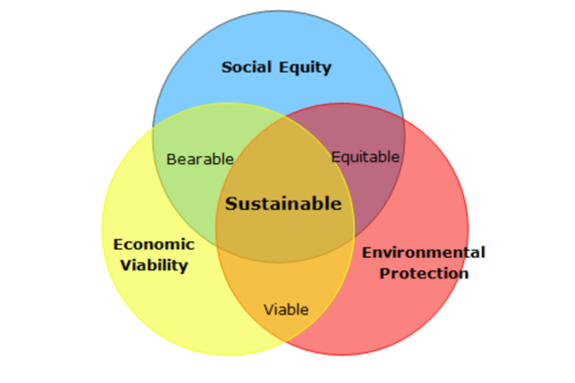

This will emphasise decarbonisation within the sourcing, manufacturing process and emissions from the vehicles post-sale. Sustainable practices within the value chain will be analysed to implement eco-friendly sourcing(Autovista24, 2022).

The automotive industry includes activities that manufacture transportation vehicles and its parts(Binder & Rae, 2018). It is set to grow to $39 billion by 2030, making it a fast-growing market (Precedence Research, n.d) and the market contributes to 17.8% of all Greenhouse Gases(GHG) (European Parliament, 2018), accelerating the rate of climate change and its impacts across the world.

The focus of reducing GHG would provide transformations in employment and capital expenditure. Companies that have switched to sustainable operations has reduced profitability and vehicle production therefore it is important to analyse new opportunities in the sector (EY, n.d.).

# 2 Sustainability Goals

Climate action refers to the initiatives taken to tackle climate change, which refers to the alteration of global temperatures due to human activity (Our World In Data Team, 2023).

Setting these goals has resulted in the industry forcibly adapting by transforming their business models and heavily investing in R&D to incorporate sustainability to stay competitive in the modern era’s technological landscape to meet customer demand and comply to governmental bodies. Organisations have revised their strategies across their value chains and production process to consider environmental and ethical objectives in their operations(Gohoungodji et al., 2020; Pohl, 2021). As the industry fails to meet these goals and 50% of companies risk paying fines(United Nations, 2018), they have been subject to scrutiny from many groups, pushing investors to invest in greener and fuel-efficient technologies to reduce global greenhouse gases (Capgemini, 2020).

The challenges of transitioning to sustainable practices disrupts the entire supply chain which can lead to increasing costs and cars prices resulting in lower demand for consumers to buy cars which damages profitability. These transitions will also remove jobs across the industry which can provide economic hardship for societies(Michaelson, 2023).

Disadvantages

The challenges of transitioning to sustainable practices disrupts the entire supply chain which can lead to increasing costs and cars prices resulting in lower demand for consumers to buy cars which damages profitability(reference). This rapid transformation will also misplace jobs across the industry which can provide economic hardship for societies (Jursch, 2021).

SDG 7 works to ensure that societies have increased levels of access to modern forms of energy to create a circular economy (Our World In Data Team, 2023).

Advantage

The industry will see a massive trend to transition to modern energies and manufacturing fuel-efficient solutions for cars, marking the decline of traditional cars (Moller & Schaufuss, 2022)directly impacting the manufacturing process and sourcing of materials, comprising of eco-friendly and light-weight materials (Fander & Yaghoubi, 2021). With pressure from governments and national policies, there will be 60% of EVs by 2030(Charette, 2023). Therefore, there will be an improved level of competitiveness and brand reputation for such products, improving market growth and attracting new customers.

Disadvantages

However, the rising demand of energy through economic and population growth can limit the benefits that fuel-efficient technologies provide, as producing these technologies take massive resources and contribute to GHG, making improvement difficult at a massive scale (Kay Lup et al., 2023).

# Research and Analysis - B1

Doughnut model allows for a global view of improving sustainability in the 21st century. It consists of 2 components: The inner ring represents essential human needs, such as food and education, while the outer ring sets ecological limits to prevent environmental degradation. The goal is to balance social foundations without damaging the planet to create a regenerative economy that is able to navigate with current resources. The automotive industry will be analysed to operate at an ideal level by minimising these negative impacts and providing new opportunities (Raworth, 2021)

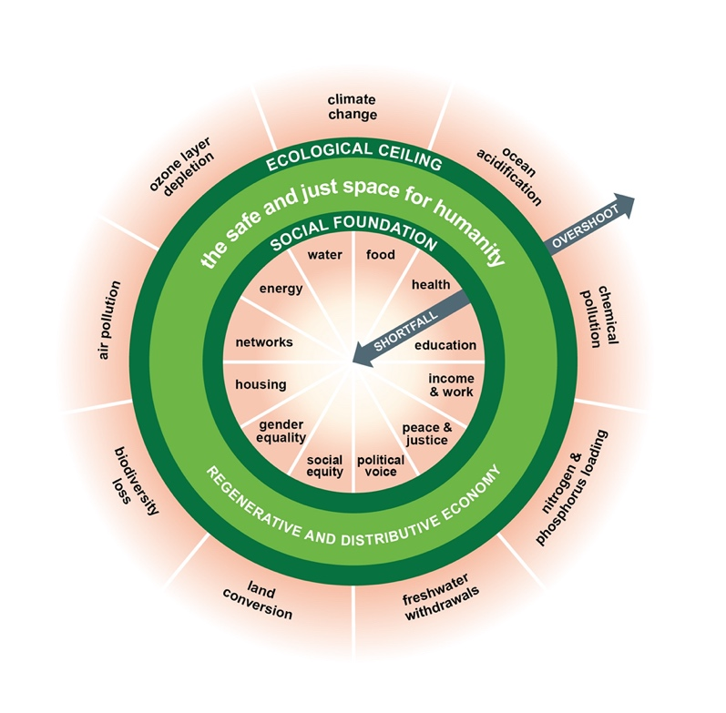

As the automotive industry contributes to 17.8% of all GHG emissions, with increasing demand and daily usage of transport due to economic progress (European Parliament, 2019), slow signs of progress have shown that they have not aligned to their goals to reduce temperature rise under 1.5 degrees(United Nations, 2018).

The industry can succeed once transitioning towards Electric Vehicles(EV) to improve the ecological ceiling. The transition towards these vehicles has exponentially reduced the global emissions as they do not produce any tailpipe emissions which reduces CO2[See Figure 1]. The industry has recorded the highest figures for miles per gallon, meaning that cars have achieved higher efficiency making their products less destructive(Ritchie , 2023). However, the demand for these have caused disruption of land and resource exploitation. The industry has disrupted 57 billion tons of land to manufacture these cars, with EV dominating the Total Mined Rock Metric(TMR) (Kosai et al., 2020) vehicle types[See Appendix 2]. This has caused the depletion of resources such as lithium, disrupting biodiversity and natural life in the process, causing more CO2 emissions to promote eco-friendly products through unsustainable practices (Kandimalla, 2023). Additionally, the industry also uses “30% of all hide leather produced in Brazil” (Weinberger & Coutler, 2023, para 2) which is depleting the Amazon Rainforest.

For the industry to continuously produce the volume of EV’s to meet demand, circular economy methods can be used by reducing waste and recycling used materials in the manufacturing process, including batteries. Alternative materials can be used to develop fuel-efficient technologies and electric batteries with materials such as aluminium and lithium-ions to reduce dependency of lithium avoiding resource exploitation(Autovista24, n.d.). By distributing their mining focus to different materials, this will reduce land disruption in certain areas (Wankhande, 2023) and solve 3 major dimensions in the outer ring such as Air Pollution, Climate Change, Biodiversity Loss and Land Conversion.

To improve social foundations, efforts towards sustainable practices will influence the demand of new jobs across this sector. There are investments worth £3 billion being invested in Research & Development. With support from governmental and private entities, knowledge sharing can be integrated for academic experts to explore new areas in the sector. As the current workforce is retiring, this entire transition will give birth to jobs in the sector. However, 39% of the industry are under 34 years old therefore it is necessary for companies to retain employees by training them(IMI, 2023).

Moreover, the industry is challenged with under-representation of females(19%) but can be steadily tackled by providing broader education towards younger audiences. By focusing on recruitment and choosing from a broader pool of talent, equality will be provided(SMMT, 2022).

This value chain will analyse the challenges that the industry faces to optimise costs and resources throughout key business activities to provide the best value towards customers while reducing environmental impact (EdrewSoft, n.d.).

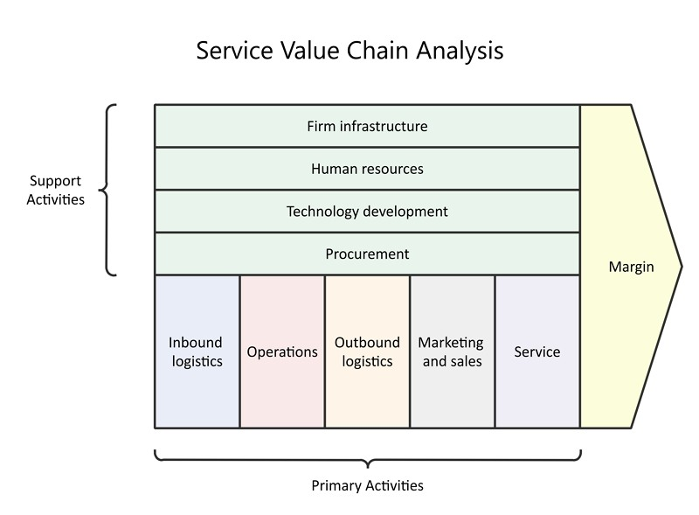

Within Sourcing and Procurement, unsustainable practices are stated to be carried within the value chain as the extraction of raw materials for these materials have been produced through child labour and poor working conditions(McKie, 2021). These problems are derived from varying opinions towards sustainability (Garber, 2021). With the increasing demand of EV and fuel-efficient technologies, it has increased difficulties to provide due diligence towards these companies.

The lack of visibility of data creates difficulty to gain an overview of suppliers activity (Integrity Next, ND) and lack of action from companies to pursue targets that they set. Before a manufacturer even receives these parts, 20% of a vehicles CO2 has already been created (Henkel, n.d.).

Therefore, it is important for organisations to set goals in their internal procurement teams and streamline communication with suppliers that contribute the most impact towards the supply chain to implement sustainability practices(Anthesis Group, 2017). Many companies in the industry do not adopt sustainability reporting(Capgemini, 2020) but visibility to work towards these goals can be achieved by purchasing an ERP System that can automate processes across the value chain and provide real-time insights allowing for data-driven decisions and optimising costs(Microsoft, n.d.).

Operations:

The manufacturing process of EV’s emit larger quantities of CO2 Emissions, consuming atleast 30% of the product lifecycle’s GHG’s(Beaudet, 2020), which is 25% higher than traditional cars (Oil and Gas Job Search, 2022). While production has been reduced, energy usage has increased significantly which has increased their operational costs[see figure 3].

Companies should be able to recycle plastics and lithium to produce more cars and batteries accordingly whilst re-using excess metals. About 65% of the cobalt needed to meet the demand for electric vehicle batteries in the United States can be satisfied by recycling of lithium-ion batteries which can be circulated around the supply chain to reduce waste (Beaudet, 2020. Business can also transition to renewable energy sources to reduce environmental impact and improve profitability (Nurdiawati & Agrawal, 2022).

Remanufacturing will also be delivered with shorter lead time and retains product longevity for customers. This reduces the carbon footprint of sourcing and transportation of materials (SMMT, 2021)

**RESEARCH AND ANALYSIS – B2**

This part of the report will assess the impacts of similar fuel-efficient technologies to O2 Band and their progress towards specific SDG Goals and Indicators. It is evident that their products directly contribute towards these targets through their operations such as:

13.2.2 – “Reduce the total greenhouse gas emissions per year” (Our World In Data 2023, para 4).

7.A – To enhance international co-operation towards renewable and fuel-efficient energy and technologies (Our World In Data, 2023,).

7.2 – Improve the energy efficiency rate by 2 times than the current rate”(Our World In Data, 2023,).

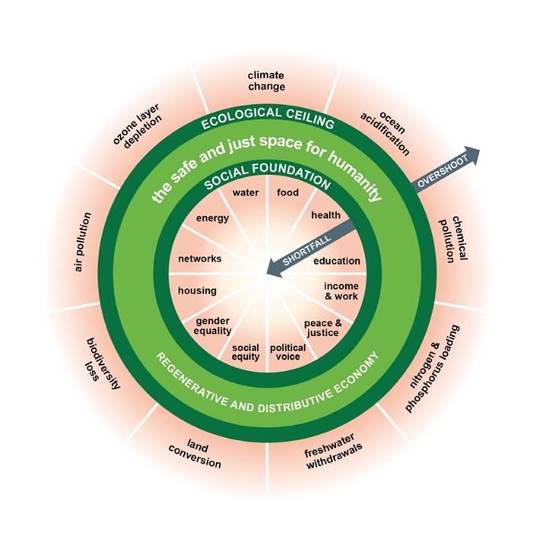

O2 Band and similar products supply components to original equipment manufacturers(OEM’s). Therefore, the company’s success on sustainability is heavily dependent upon their relationship and performance of OEM’s cars. By successfully selling their products to various OEM’s, they can reduce the ecological ceiling to move towards the inner ring.

Similar start-ups have been able to establish contracts with large enterprises in the automotive manufacturing and different sectors within the US Army(Achates Power, n.d.) which have allowed OEMs to make progress towards their own sustainability goals. One of their OEMs, Cummins, have been able to release new products that reduce emissions such as the fuel-agnostic internal combustion powertrain(Cummins, 2022). Companies such as Aramco states that the product can easily integrate into facilities and processes, enabling for faster delivery at cheaper cost. This has shown that it is possible to tackle different causes of CO2 emissions by targeting and providing solutions for all vehicles, instead of solely cars as this would limit the scope and impact for O2 Band(Tiseo, 2023) [See Figure 4]. Therefore, these suppliers indirectly contribute towards decarbonisation of road transport through other vehicles and enhance international co-operation.

These partnerships will be able to contribute to a 50% improvement in vehicle fuel economy by introducing this technology to fleets and other vehicles(Aramco, 2022). By promoting carbon-reduction technologies with easier access and affordable rates, O2 Band contribute to accelerating progress in energy-efficiency. Moreover, companies will be able to estimate the number of emissions they can avoid, along with scope 3 emissions more accurately, allowing them to progress further of decarbonisation in fleets and light-vehicles at a larger scale.

As O2 Band is mainly focused on heavily reducing emissions for traditional vehicles, they do not have products that directly optimise use of cleaner fuels. The product may be used as an incentive to move away from EVs. Traditional vehicles produce 61% more carbon footprint during the product lifecycle, which will hinder the industry’s efforts towards promoting fuel-efficiency and decarbonisation and create more environmental harm(Jolly, 2021). Companies such as ClearFlames has been able to reduce 35,000 pounds of carbon per year through this(ClearFlame, n.d.).

To adapt to consumer demand and industry changes, O2 Band must be able to accommodate OEMs with electrification strategies. Companies that have done so have gained a diverse product portfolio and multiple revenue streams. While EVs do not emit CO2, there are opportunities to decarbonise other aspects of the product lifecycle. By taking advantage of the market opportunity, they will be able to partner with more companies and improve their profitability, benefitting from economies of scale and producing at a lower cost and increasing output which can allow them to sell their products to other OEMs internationally, strengthening partnerships and decreasing global GHG.

If O2 Band implements products across different vehicle types, through collaboration with governments and organisations, cleaner transportation will be available to more people. To improve the social foundation, the product should be distributed at cheap prices in low-income countries for private and public transport, improving energy efficiency. In addition, new jobs in the sector for both traditional and electrical vehicles will open with the mass introduction of the product, which will increase the demand for new skills that are related to fuel-efficiency and renewable energy in the industry.

The adoption of this technology will reduce air pollution as there will be significant reduction by tackling root causes of this. More than 60,000 people die per year and face many health complications due to air pollution(Ties, 2021), which will significantly decrease and improve the health and safety dimension.

**STAKEHOLDER THEORY**

Stakeholder theory is a tool used to identify the relationships and needs between internal and external entities who have a stake in the organisation(Nandy, 2021). O2 Band is a supplier of automotive parts towards car manufacturers and must ensure their products retain the highest quality through new design engineering methods. By satisfying employees, customers, and local communities will be able to realise the shared value creation within the relationship. They have contributed to: By 2030, directly contribute to education and impact reduction of climate change(Our World in Data, 2023).

O2 Band contribute to education towards awareness-raising and impact reduction of climate change by developing training programs to apply new skills in product design and encourage understanding of sustainable practices, ensuring teams will align towards their goals. Larger companies in the industry have invested in 84,000 hours of training or running sessions for most of the workforce(Borgwarner, 2023). The results of this were that 90% of employees were motivated to apply these new skills. Continuous development and investment of research will improve their product quality and ensure they can minimise environmental impacts more effectively(Cummins, 2022). Employees will be able to foster a culture of knowledge sharing and innovate new solutions within the industry.

The result of training and development was improvement in sustainability performance such as technology advancement and functionality, and positively impacted customer satisfaction(Delphi Technologies, 2019). O2 Band has capacity to collaborate within educational institutions to improve research and education to foster new solutions in the market. However, not many in the industry of that scale has made reasonable progress towards this goal, especially towards early education which hinders progress towards this SDG Goal, therefore industry experts should be able to interact with local communities and educate them about sustainable design(The Engineer, 2023).

CONCLUSION

The company aims to place their product across 1.5 billion internal combustion engines. Similar companies such as Achates Power projects that there will be 3 billion combustion engine cars in the future. This is an ambitious goal derived from the total amount of cars on the planet. Currently, demand for these products is high but will steadily decline due to the rapid transition towards electrification. By 2040, over 65% of light-vehicles will be electric(Fugay, 2023), leaving limited room for growth for O2 Band.

O2 Band states that their product can ensure higher levels of performance, research has shown the contrary. While there are levels of noise reduction, but the overall speed and capacity of engines have been compromised which can leave customers dissatisfied (Wu et al., 2021).

While fuel reduction technologies align with the UN Sustainability Goals and continue to partner to make environmental impact for companies, large suppliers continue to heavily invest in research to go beyond and innovate with newer tools to comply with new and continuously changing regulations from governments. This includes creating new engines and parts but have only achieved less than 10% efficiency during use, as opposed to O2 Band where the product is simply a patch but is stated to improve fuel-efficiency by 70%. Claims about fuel-efficiency must be verified by a third-party through audit and testing to confirm the authenticity of the product. These statements from O2 Band are most likely used to improve marketing strategies to improve sales, as their claims have been refuted by experts in the industry and academia. Thus, O2 Band must set new goals to align themselves more closely with the SDG Goals.

By 2030, increase investment of annual R&D budget by 20% develop clean and efficient technologies beyond internal combustion engines. This initiative will allow O2 Band to implement broader strategies to combat climate change and adapt with new demands of the market, resulting in higher attraction from investors and regulatory bodies. They will benefit from diversified product portfolio and revenue streams, improving profitability. This can provide an increase in salary and training towards staff to retain their talent and continuously innovate in the market and will allow the industry to move closer towards the 1.5-degree scenario.

By 2030, strategically partner with institutions from early education to raise awareness and develop new strategies for climate change. O2 Band will be able to develop industry expertise through this initiative and encourage new opportunities across the market. This will give birth to rise in new skills and innovations across the market, and the presence of fuel-reduction companies will rise. This increases economic output while tackling climate change for generations to come, improving future GHG and reducing health and planetary consequences of global warming.

By 2030, make engine reduction technologies for internal combustion, biofuels, hydrogen and electric vehicles 30% more accessible. This will enable people to access cleaner energy sources to reduce carbon emissions at an affordable price, improving financial well-being and direct savings to spend towards the economy. Additionally, this will reduce air and noise pollution in communities which will improve health and living conditions for societies which contributes to lower healthcare costs. This initiative will provide improved branding and competitiveness in the market, allowing for international opportunities.

REFERENCES

1. Ritchie, H. (2023, August 25). Do electric vehicles reduce air pollution? Www.sustainabilitybynumbers.com. <https://www.sustainabilitybynumbers.com/p/electric-vehicles-air-pollution#:~:text=There%20might%20be%20no%20tailpipe>
2. Jursch, S. (2021). Sustainability in the Automotive Industry. PwC. <https://www.pwc.de/en/sustainability/sustainability-in-the-automotive-industry.html>
3. Achates Power. (n.d.). Multimedia Assets. <https://achatespower.com/resources/>
4. Aramco. (2022, April 25). Near-zero emissions engine of Aramco partner Achates enters fleet service. <https://americas.aramco.com/en/news-media/news/2022/near-zero-emissions-engine-achates>
5. ClearFlame. (n.d.). Clean Energy Technology for Power Generation. <https://clearflame.com/solutions/power-generation/>
6. Faguy, A. (2023, April 12). Planned EPA Rules Could Make 67% Of New U.S. Cars Electric By 2032. Forbes. [https://www.forbes.com/sites/anafaguy/2023/04/12/biden-proposes-standards-designed-to-make-most-new-us-cars-electric-by-2032/#](https://www.forbes.com/sites/anafaguy/2023/04/12/biden-proposes-standards-designed-to-make-most-new-us-cars-electric-by-2032/)
7. Freeman, R. E. (2018). Stakeholder Theory. Stakeholdertheory. <http://stakeholdertheory.org/about/>
8. Aramco. (n.d.). Transport technologies. <https://europe.aramco.com/en/creating-value/technology-development/transport-technologies>
9. Capgemini. Sustainability in Automotive Industry from Ambition to Action(n.d.) <https://prod.ucwe.capgemini.com/wp-content/uploads/2022/10/CRI_Sustainability-in-Automotive_18102022.pdf>
10. Beaudet, A., Larouche, F., Amouzegar, K., Bouchard, P., & Zaghib, K. (2020). Key Challenges and Opportunities for Recycling Electric Vehicle Battery Materials. Sustainability, 12(14), 5837. <https://doi.org/10.3390/su12145837>
11. Our World in Data team (2023).Take urgent action to combat climate change and its impacts. <https://ourworldindata.org/sdgs/climate-action>
12. Cummins. (2023). *2022-2023 Sustainability Progress Report*. <https://www.cummins.com/sites/default/files/2023-09/SPR23-2022-2023-Cummins-Sustainability-Progress-Report-9112023.pdf>
13. Wu, J., Posen, I. D., & MacLean, H. L. (2021). Trade-offs between vehicle fuel economy and performance: Evidence from heterogeneous firms in China. Energy Policy, 156(0301-4215), 112445. <https://doi.org/10.1016/j.enpol.2021.112445>
14. IMI. (2023). Automotive sector employment 2021-2031 Employment forecasts and principal skills requirements. <https://tide.theimi.org.uk/sites/default/files/2022-07/Automotive%20Sector%20Employment%202021-31_0.pdf>
15. Our World in Data team (2023) Ensure access to affordable, reliable, sustainable and modern energy for all. <https://ourworldindata.org/sdgs/affordable-clean-energy>
16. Bocken, N. M. P., de Pauw, I., Bakker, C., & van der Grinten, B. (2016). Product Design and Business Model Strategies for a Circular Economy. Journal of Industrial and Production Engineering, 33(5), 308–320. <https://doi.org/10.1080/21681015.2016.1172124>
17. Fander, A., & Yaghoubi, S. (2021). Impact of fuel-efficient technology on automotive and fuel supply chain under government intervention: A case study. Applied Mathematical Modelling, 97, 771–802. <https://doi.org/10.1016/j.apm.2021.04.013>
18. Charette, R. (2023, March 28). The EV Transition Is Harder Than Anyone Thinks - IEEE Spectrum. Spectrum.ieee.org. <https://spectrum.ieee.org/the-ev-transition-explained-2659602311>
19. SMMT. (2021). 2021 UK Automotive Sustainability Report 22nd Edition <https://www.smmt.co.uk/wp-content/uploads/sites/2/SMMT-Sustainability-Report-2021.pdf>
20. Kay Lup, A. N., Soni, V., Keenan, B., Son, J., Taghartapeh, M. R., Morato, M. M., Poya, Y., & Montañés, R. M. (2023). Sustainable energy technologies for the Global South: challenges and solutions toward achieving SDG 7. Environmental Science: Advances, 2. <https://doi.org/10.1039/d2va00247g>
21. SMMT. (2022, July 11). UK automotive manufacturing carbon footprint falls to lowest ever level. SMMT. <https://www.smmt.co.uk/2022/07/uk-automotive-manufacturing-carbon-footprint-falls-to-lowest-ever-level/>
22. Raworth, K. (2021). About doughnut economics. Doughnut Economics Action Lab. <https://doughnuteconomics.org/about-doughnut-economics>
23. McGill University. (n.d.). What Is sustainability? <https://www.mcgill.ca/sustainability/files/sustainability/what-is-sustainability.pdf>
24. Moller, T., & Schaufuss, P. (2022, August 1). The automotive sector’s net-zero transition: Shifting to low-emission vehicles. Mckinsey. <https://www.mckinsey.com/capabilities/sustainability/our-insights/spotting-green-business-opportunities-in-a-surging-net-zero-world/transition-to-net-zero/road-mobility>
25. SMMT (2022). 20th Sustainability Report. SMMT. <https://www.smmt.co.uk/reports/sustainability/>
26. Ties, I. (2020, October). U.S.: Air pollution deaths 2019. Statista. <https://www.statista.com/statistics/1137375/air-pollution-deaths-united-states/#:~:text=The%20number%20of%20deaths%20attributable>
27. Pohl, T. (2021, December 1). How The Automotive Industry Is Driving Toward A Sustainable Future. Forbes. <https://www.forbes.com/sites/sap/2021/12/01/how-the-automotive-industry-is-driving-toward-a-sustainable-future/>
28. The Engineer. (2022, May 31). Accelerating technological advances with industry academia collaboration. <https://www.theengineer.co.uk/content/opinion/guest-blog-accelerating-technological-advances-with-industry-academia-collaboration/>
29. Michelson, J. (2023, September 22). 4 Ways Auto Sector Jobs Are Changing, According To A Top GM Executive. Forbes. <https://www.forbes.com/sites/joanmichelson2/2023/09/22/4-ways-auto-sector-jobs-are-changing-according-to-a-top-gm-executive/>
30. Autovista24 . (2022, August 9). Sustainable materials are driving change in the automotive industry. <https://autovista24.autovistagroup.com/news/sustainable-materials-driving-change-in-automotive-industry/>
31. Anthesis Group. (2017, November 17). How to Improve the Sustainability of Supply Chains. <https://www.anthesisgroup.com/how-to-improve-the-sustainability-of-supply-chains/>
32. ClearFlame. (n.d.). ClearFlame Truck Engine That Can Run on Straight Ethanol Passes Torque, Power Test. DTN Progressive Farmer. <https://www.dtnpf.com/agriculture/web/ag/news/business-inputs/article/2020/10/14/clearflame-truck-engine-can-run-test>
33. McKie, R. (2021, January 3). *Child labour, toxic leaks: the price we could pay for a greener future*. The Guardian. <https://www.theguardian.com/environment/2021/jan/03/child-labour-toxic-leaks-the-price-we-could-pay-for-a-greener-future>
34. Oil and Gas Job Search. (2022, September 28). Energy consumption in the automotive industry. <https://blog.oilandgasjobsearch.com/energy-consumption-in-the-automotive-industry/>
35. Henkel. (n.d.). Delivering sustainability along the automotive value chain. <https://www.henkel-adhesives.com/mx/en/applications/all-applications/industry-insights/delivering-sustainability-along-the-automotive-value-chain.html>
36. Aramco. (2022, April 25). Near-zero emissions engine of Aramco partner Achates enters fleet service. <https://americas.aramco.com/en/news-media/news/2022/near-zero-emissions-engine-achates>
37. Veloso, Francisco & Engenharia, Licenciatura & Tecnolgica, Fsica & Amsden, Alice & Clark, Joel & de Neufville, Richard & Hastings, Daniel. (2001). Local Content Requirements and Industrial Development Economic Analysis and Cost Modeling of the Automotive Supply Chain.
38. Nurdiawati, A., & Agrawal, T. K. (2022). Creating a circular EV battery value chain: End-of-life strategies and future perspective. Resources, Conservation and Recycling, 185, 106484. <https://doi.org/10.1016/j.resconrec.2022.106484>
39. EY. (n.d.). How to make automotive companies sustainable. <https://www.ey.com/en_uk/automotive-transportation/how-to-make-automotive-companies-sustainable>
40. European Parliament. (2019, March 22). CO2 emissions from cars: facts and figures. <https://www.europarl.europa.eu/news/en/headlines/society/20190313STO31218/co2-emissions-from-cars-facts-and-figures-infographics>
41. Precedence Research. (2023). Automotive Motors Market Size, Growth, Trends, Report 2022-2030. <https://www.precedenceresearch.com/automotive-motors-market>
42. Tiseo, I. (2023, April 26). U.S. on-road GHG emissions by vehicle type. Statista. <https://www.statista.com/statistics/1120499/us-road-vehicle-ghg-emissions-by-vehicle-type/#:~:text=Light%2Dduty%20trucks%20in%20the>
43. Microsoft (n.d.). ERP in Supply Chain Management. <https://dynamics.microsoft.com/en-us/erp/erp-supply-chain-management/>
44. <https://www.edrawmax.com/article/service-industry-value-chain-analysis.html>
45. Weinberger, A. & Coutler, C.(2023, June). Why decarbonization alone won’t make automotive companies sustainable. EY. <https://www.ey.com/en_uk/automotive-transportation/how-to-make-automotive-companies-sustainable#:~:text=In%20the%20environmental%20space%2C%20for,rainforest%20depletion%20in%20the%20Amazon>.
46. United Nations Climate Change. (2018, January 18). Global Car Industry Must Shift to Low Carbon to Survive - CDP | UNFCCC. Unfccc.int. <https://unfccc.int/news/global-car-industry-must-shift-to-low-carbon-to-survive-cdp>
47. Edrawsoft. (n.d.). Service Industry Value Chain Analysis. <https://www.edrawmax.com/article/service-industry-value-chain-analysis.html>
48. Jolly, J. (2021, March 1). *Fossil fuel cars make “hundreds of times” more waste than electric cars*. The Guardian. <https://www.theguardian.com/business/2021/mar/01/fossil-fuel-cars-make-hundreds-of-times-more-waste-than-electric-cars>
49. Capgemini. (2020). The Automotive Industry in the Era of Sustainability. <https://www.capgemini.com/gb-en/wp-content/uploads/sites/3/2020/03/Report-The-Automotive-Industry-in-the-Era-of-Sustainability.pdf>
50. Kosai, S., Matsui, K., Matsubae, K., Yamasue, E., & Nagasaka, T. (2020). Natural resource use of gasoline, hybrid, electric and fuel cell vehicles considering land disturbances. Resources, Conservation and Recycling, 166, 105256. <https://doi.org/10.1016/j.resconrec.2020.105256>
51. Tiseo, I. (2023, April 26). U.S. on-road GHG emissions by vehicle type. Statista. <https://www.statista.com/statistics/1120499/us-road-vehicle-ghg-emissions-by-vehicle-type/#:~:text=Light%2Dduty%20trucks%20in%20the>
52. Kandimalla, S. (2023, March 8). *Unsustainable Mining Is Driving the Electric Vehicle Boom*. New University. <https://newuniversity.org/2023/03/08/unsustainable-mining-is-driving-the-electric-vehicle-boom/#:~:text=The%20mining%20process%20disrupts%20biodiversity>
53. Lenort, R., Wicher, P., & Zapletal, F. (2023). On influencing factors for Sustainable Development goal prioritisation in the automotive industry. Journal of Cleaner Production, 387, 135718. <https://doi.org/10.1016/j.jclepro.2022.135718>
54. 24-7 Press Release. (2023, November 1). Innovative Solution for Improving Automotive Fuel Efficiency, O2 BAND Pro, Launches on Indiegogo. <https://www.24-7pressrelease.com/press-release/505619/innovative-solution-for-improving-automotive-fuel-efficiency-o2-band-pro-launches-on-indiegogo>
55. Zandt, F. (2021, October 22). Infographic: Diesel And Petrol Cars Losing Ground in the EU. Statista Infographics. <https://www.statista.com/chart/26037/market-share-of-cars-registered-in-the-eu-by-fuel-type/>
56. Nandy, S. (2021, July 23). *All you need to know about the stakeholder theory*. IPleaders. <https://blog.ipleaders.in/need-know-stakeholder-theory/>

APPENDIX

Appendix 1

SMMT, 2022

Appendix 2

(Kosai et al, 2022)

Appendix 3

SMMT, 2022

Appendix 4

Appendix 6

Our World In Data, 2023

Appendix 7

Our World In Data, 2023